Technical Story Card

Revision History
Version No. | Date | Prepared by / Modified by | Significant Changes

Glossary
Abbreviation | Description
BSC | Business Story Card
TSC | Technical Story Card

Table of Contents
1 Introduction 3
2 Scope of Change 3
3 List of impacted modules 3
4 Design and Detailed technical updates 4
4.1 Process model 4
4.1.1 Use case Model 4
4.1.2 Sequence diagram 4
4.2 Proposed user Interface design 4
4.3 Database design changes 4
4.4 Refactoring related changes 4
4.5 Construction strategy and re-use 4
5 Details of Alternative Design Approach 4
6 Other Technical changes 5
6.1 Automation tasks / changes 5
6.2 CI / Build relates tasks / changes 5
6.3 Non-functional related changes 5
7 Additional details 5
7.1 Open Questions / clarifications / Assumptions 5
7.2 Additional notes to technical team 5
8 References 5

Introduction
The concept of traditional education has changed radically within the last couple of years. Being physically present in a classroom isn’t the only learning option anymore — not with the rise of the internet and new technologies, at least. Nowadays, you have access to a quality education whenever and wherever you want, as long as you can get online. We are now entering a new era — the revolution of online education.
There’s no need to discount the skepticism surrounding education through the internet. It’s hard to understand the notion of leaving behind the conventional classroom, especially if it's to face this vast space called The Internet.
However, that’s not reason enough to shy away from this alternative, which has proven to be valid and useful for many students. According to the most recent survey from Babson Survey Research Group, over 30 percent of higher education students in the United States are taking at least one distance course. Online education is a sensible choice whether you’re a teenager or an adult. As a student, this can be a useful learning method for sharpening your skills in a difficult subject, or learning a new skill.

Scope of Change
Change will not be entertained and whatever specifications mentioned in this document is final.

List of impacted modules
All the functional modules will be created from scratch.

Design and Detailed technical updates

Process model

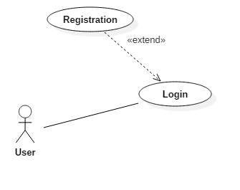
Brief Description | Client Registration
Basic Flow | This use case describes how a client register in to the system  - The client has to register himself into the system.  - After the successful registration, client will get a success message.  - The following information is required during registration.  - Name  - Email  - Password
Alternate Flow | - The system will validate the information provided. If any invalid data is found, the input form will be redirected with error message.
Validation | - Name is required and minimum 3 characters and max 30 characters.  - The Email should be valid.  - Password should have minimum 4digit and maximum 8digit.
Pre-Conditions | User should have network access and Browser with latest updates.
Post-Conditions | Success message should be shown.

5. Architecture Diagram

Layer
Logical View
Technology/ Framework

UI Components
Presentation Layer
HTML/ CSS/ JavaScript/ AJAX/ Angular
Export (pdf)
Validations
Resources

Report

Web-Server Classes
Java 1.8/ Spring MVC
Application/ Business Layer
Configuration
Controllers

Service
REST Controllers

Entity/ Model Classes

Data Access Layer
Repository classes
Hibernate ORM

Oracle 11g Database

6.Database design
Student Table

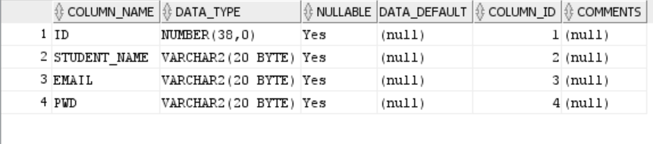
Course Table
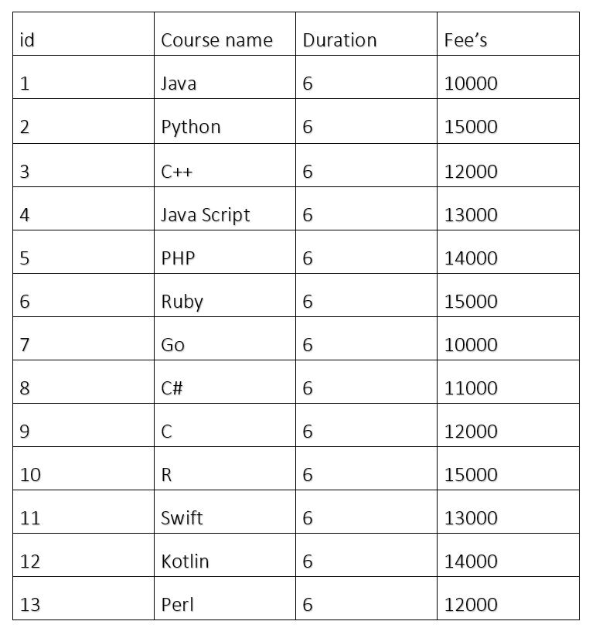

7.Entity-Relationship Diagram
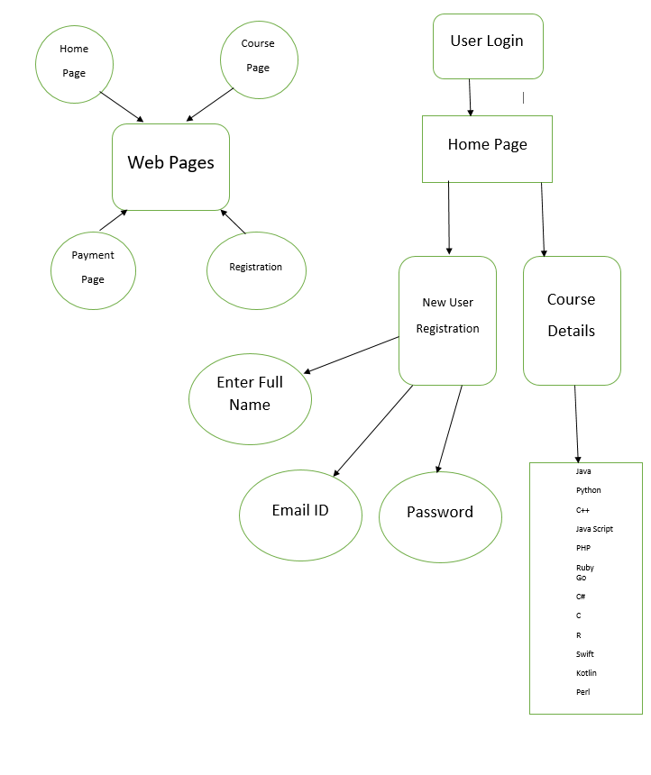

8. Activity Diagram
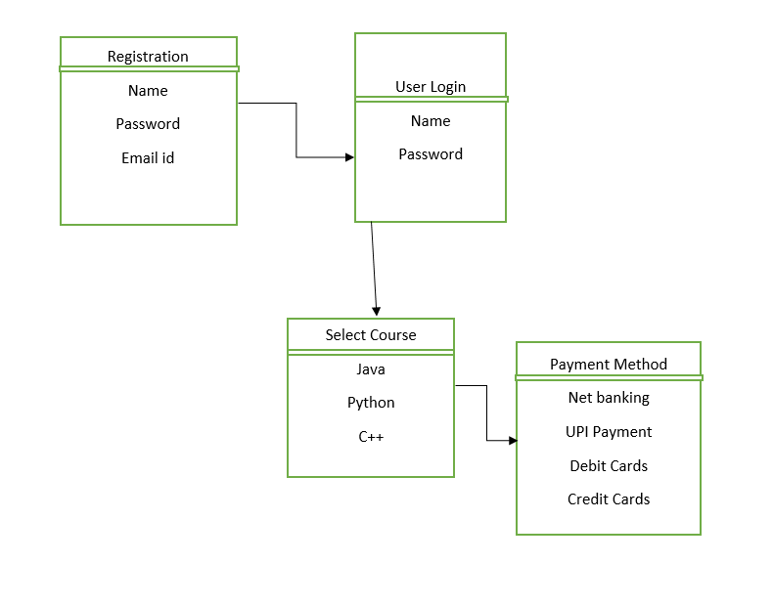

9.Additional details

Software Requirements
- Windows version 10+.
- A browser which supports CGI, HTML & JavaScript.
- Front-end software: Angular
- Back-end software: Oracle Database

Non Functional Requirements
- AVAILABILITY: The flight should be available on the specified date and specified time as Admin may need it any time.
- CORRECTNESS: Correct data should be displayed.
- MAINTAINABILITY: The administrators should maintain correct data.
- USABILITY: Can be used by Admin.

10.References
NON

11.TEAM MEMBERS
1.Shalini Shree
2.Voora Yugandhar
3.Sungu Ranga Prabhas

